FRONT END MATERIAL THAT IS SHOWN FROM YOUTUBE:::

\*LIKE making profile dropdown from this linkhttps://www.youtube.com/watch?v=ybXulmeilFM(tu is me ham ne toggle function ko follow ni karna balke vo function ham ne below video link me dekhni he)

\* like adding functionality(when we click on profile and click on any side of page profile dropdown will close ) in profile dropdown https://www.youtube.com/watch?v=8a6R2P9YqGY

\*

>>>>now how i add second header after login that name is <header> so for this

>so first I create two header components

>then auth.service.ts file I services folder

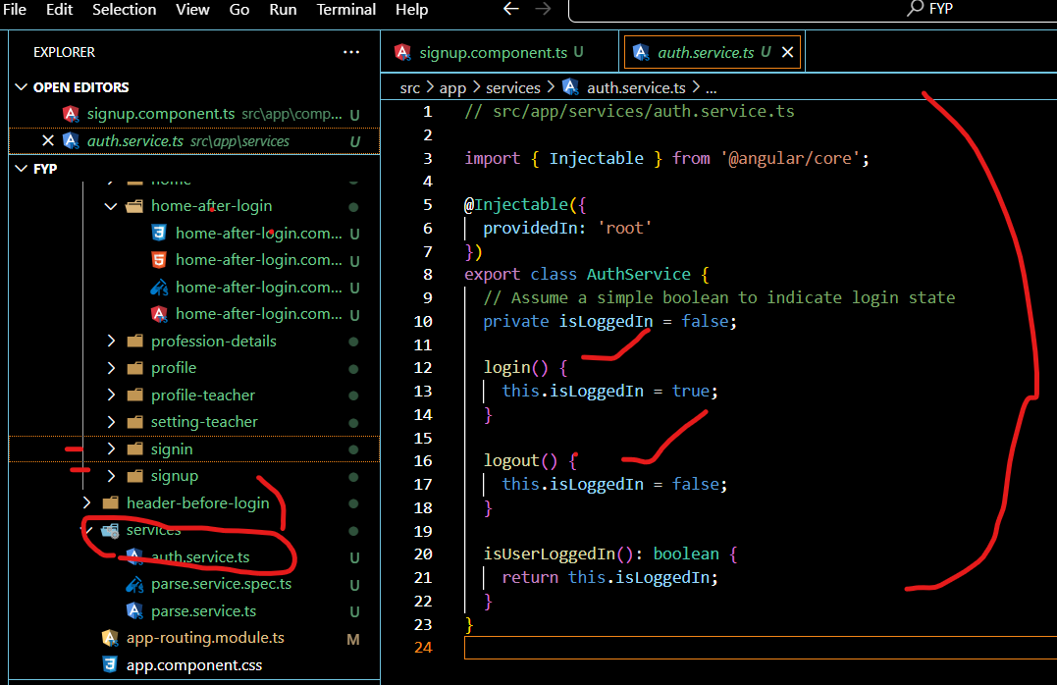

* After that I put code in main file of app-component.ts
* 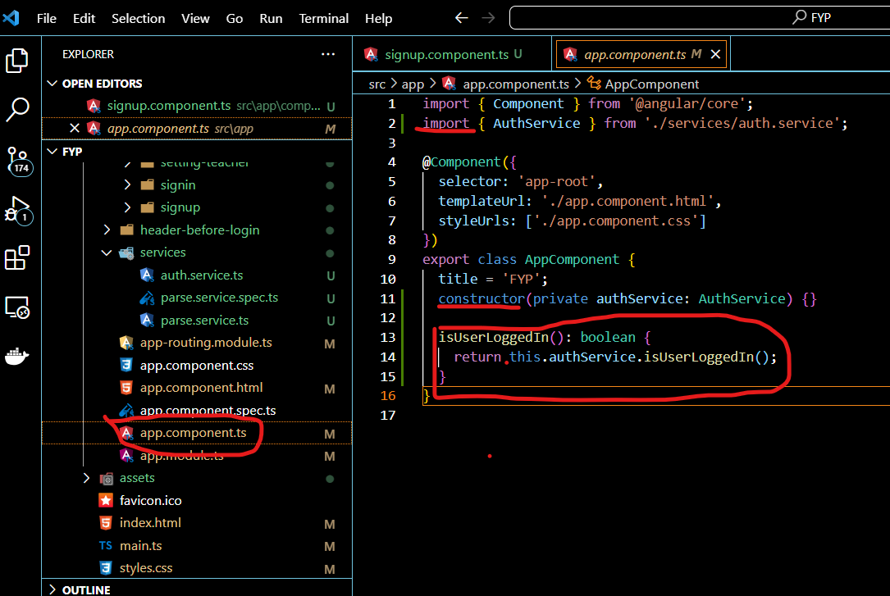

>now after this I call two header in app.compomnent.html

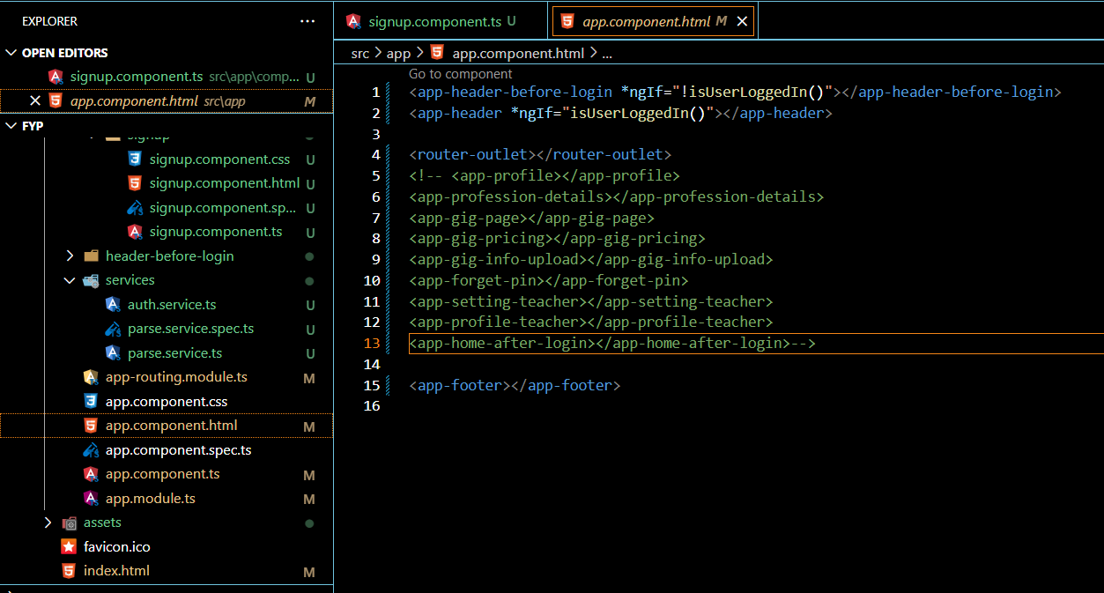

* So I want to show second header after login so I change setup in sigin and signup components :
* For SIGIN as weel as same changes for signup
* 